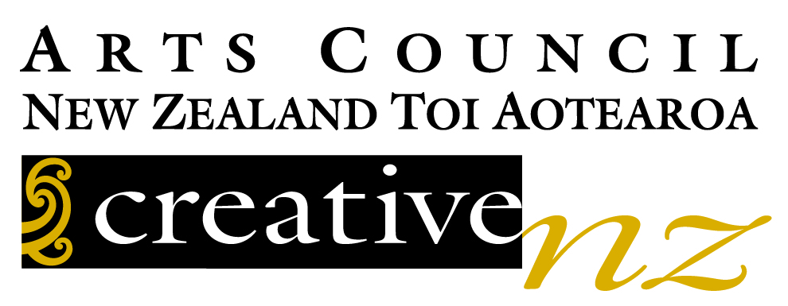

Translation Fund Application Form

Please fill in this form and email to admin@publishers.org.nz with supporting documents (see Attachments Checklist).

Complete all application fields and attach all requested documents. INCOMPLETE APPLICATIONS WILL NOT BE CONSIDERED. You can browse through the form below before filling it in to ensure you have all the required information.

Applications are contestable and all decisions are final.

Full acknowledgement to Creative New Zealand, including logo placement, must be included in the translated book to receive funds.

The Translation Fund is one of the opportunities administered by the Publishers Association of New Zealand (PANZ) as part of a Contract for Services with Creative New Zealand to deliver Capability Building and International Market Development Initiatives for Literature 2021 – 2022.

Publisher Details
Company Name
Address
Contact Name
Telephone
Email
Website URL

Book Details
Title
Author
Language of Translation
Planned Publication Date (in the format DD/MM/YYYY)
Number of Words (Prose) or Number of Lines (Poetry)
Estimated Translation Cost (state currency and amount)
Number of Print Copies (1st edition)

Translator Details
Name
Address
Telephone
Email
Qualifications
Main Titles Translated Previously

Any Other Funding for This Title
Funders and Amounts Granted

Attachments Checklist
Licence Agreement
Translator Contract
Translator’s CV
Translation Sample (8-10 pages) and corresponding passage in English
Publisher Profile
Publicity Plan
Publisher Catalogue or Website URL
Your contact information is collected and held by the Publishers Association of New Zealand Te Rau o Tākupu. We use those details to keep you informed about PANZ’s activities and will not share any information with other organisations without obtaining your consent.
You are entitled to ask for a copy of any personal information we hold, please just get in touch if you’d like to check anything at any time – Catriona@publishers.org.nz or +642102482637 or PO Box 33319, Takapuna, Auckland. We will be happy to correct any information that is incorrect.

